Connecting to Rest API of atomic hub

Contents

1. Installing the request module using pip 3

# Installing the request module using pip

Controlling the API

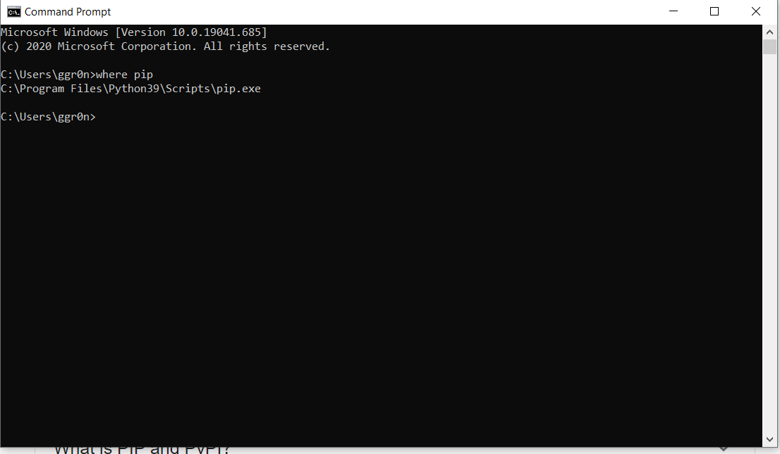

You can locate where pip using the command where pip after you download the python file and install it at <https://www.python.org/downloads/>

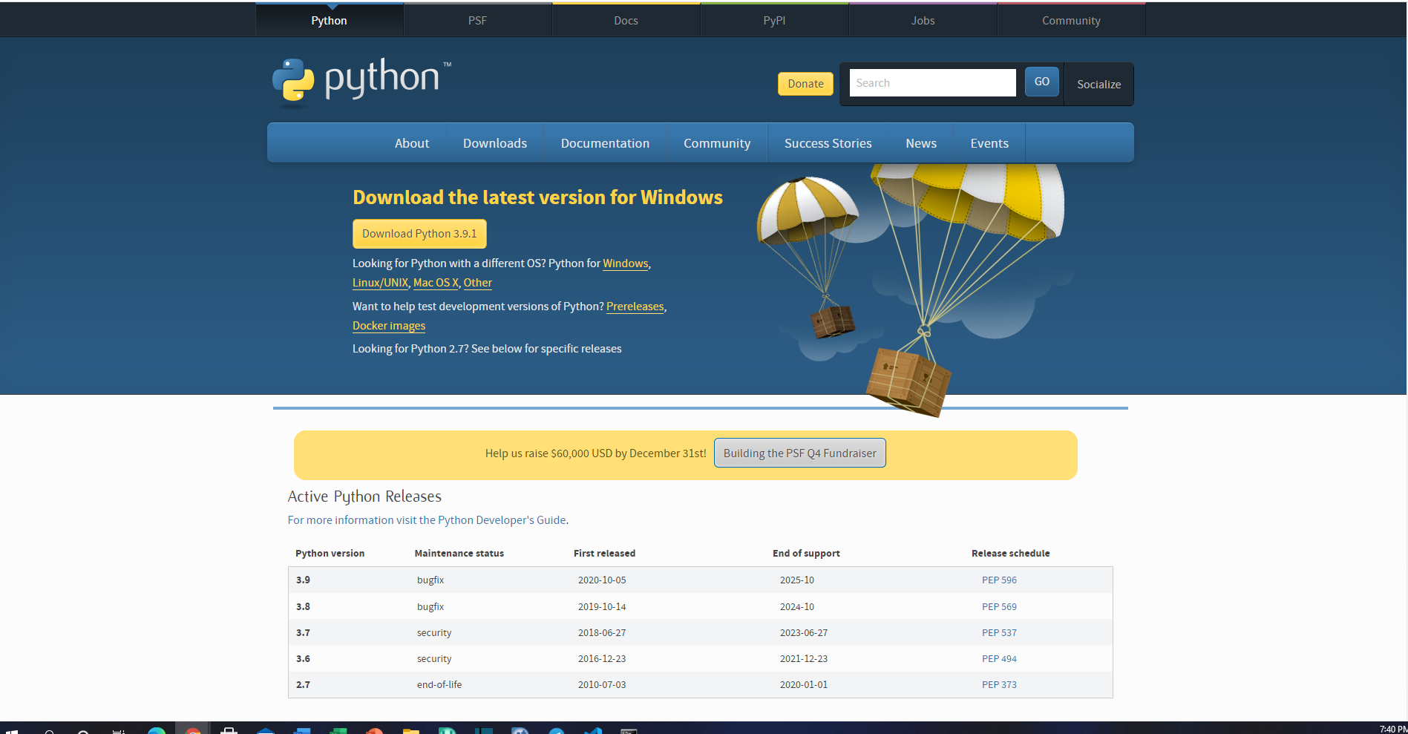

<https://www.python.org/downloads/>

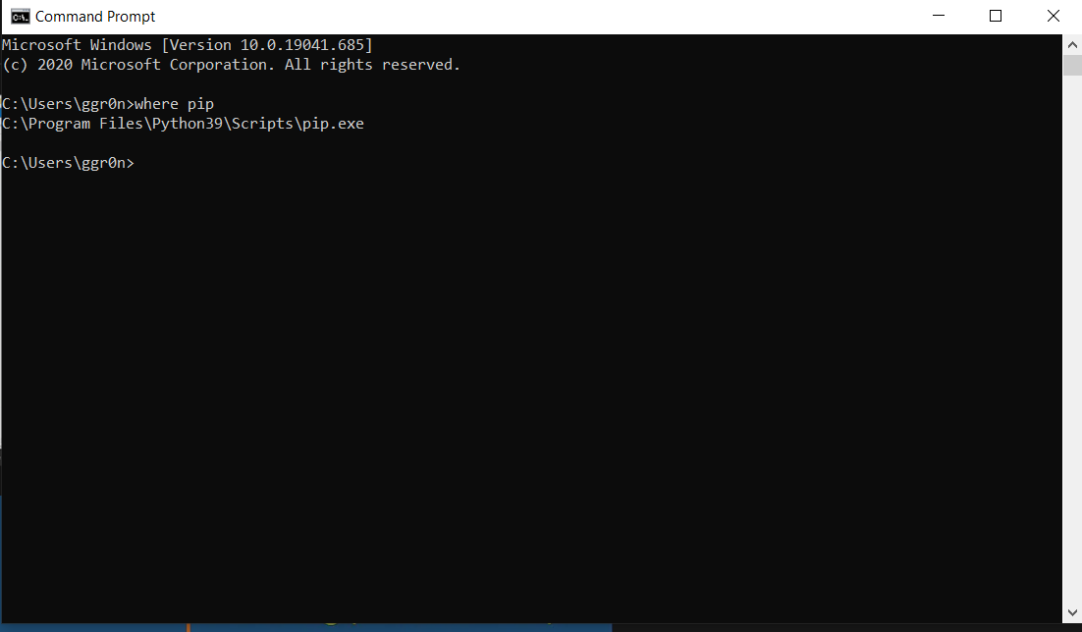

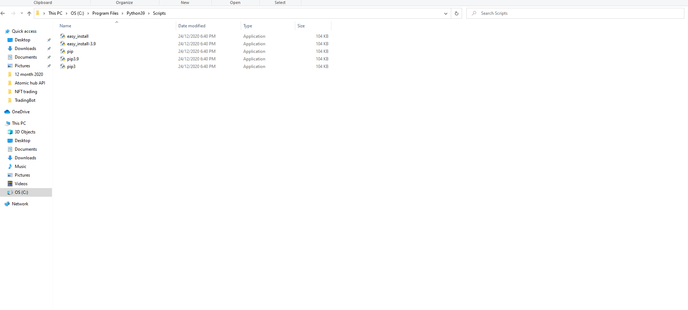

Before starting any coding we need to install the request module or library cause the request library help us to get data from the rest API or https. In order to do this we need to use pip tools.

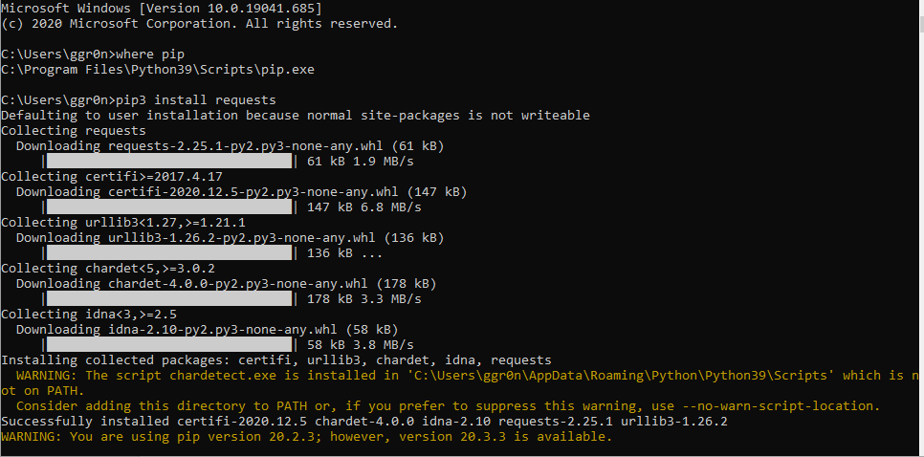

If the yellow warning pop up don’t mind it as the requests module is download somewhere else as long as you get the successfully installed. To test the downloaded library use command prompt python and try import requests

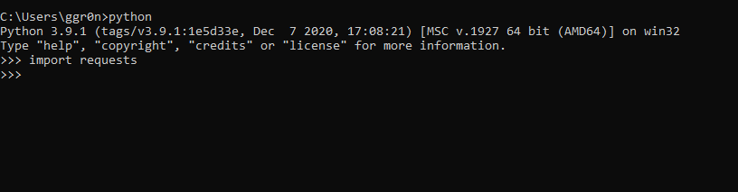

If no error prompt up means the requests library is successfully installed and usable.

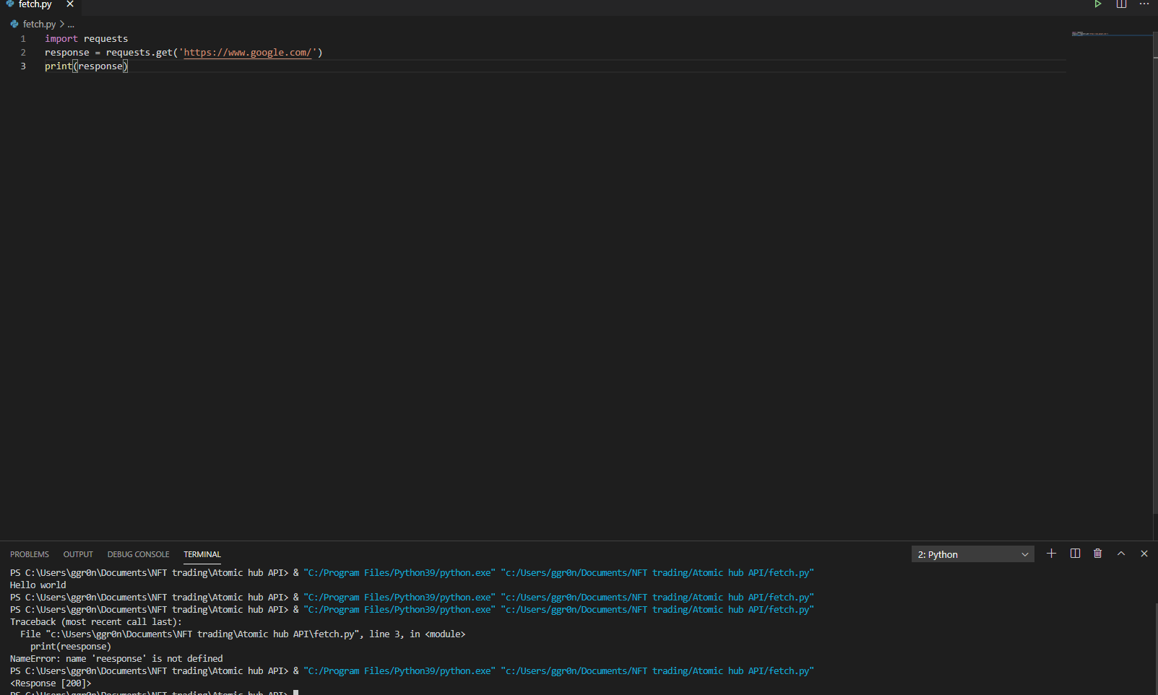

Simple testing in Visual studio code using the request prompt and get request from google

# Getting response from the API

<https://wax.api.atomicassets.io/atomicmarket/docs/swagger/#/>

or join telegram first go to the API website and copy and paste the link

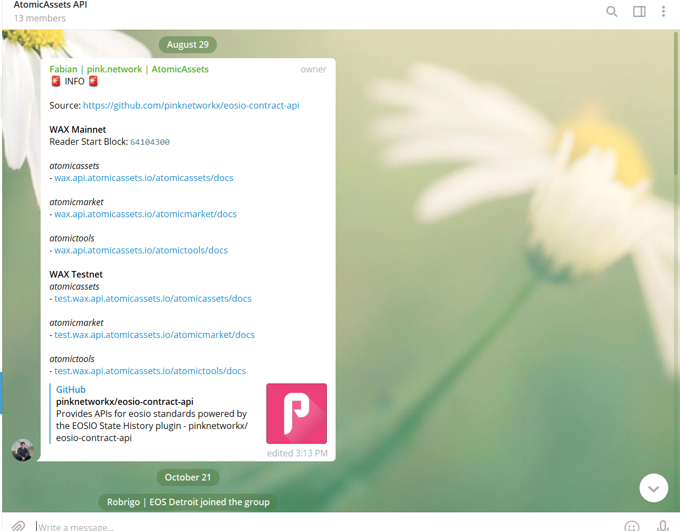

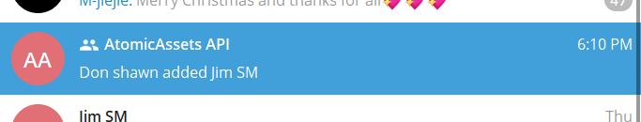

Mannually type in the url or get the link

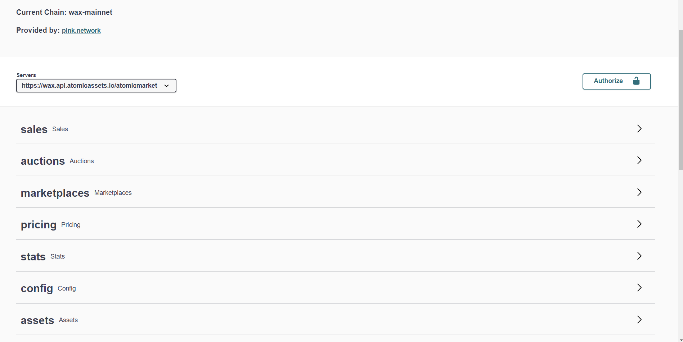

# To get the listing price of a particular item

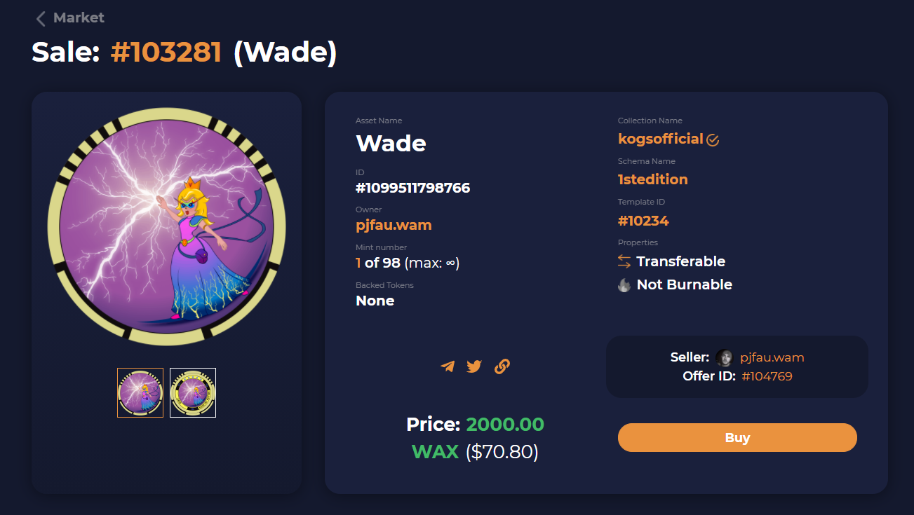

Taking an example of a Wade card in Kogs first edition

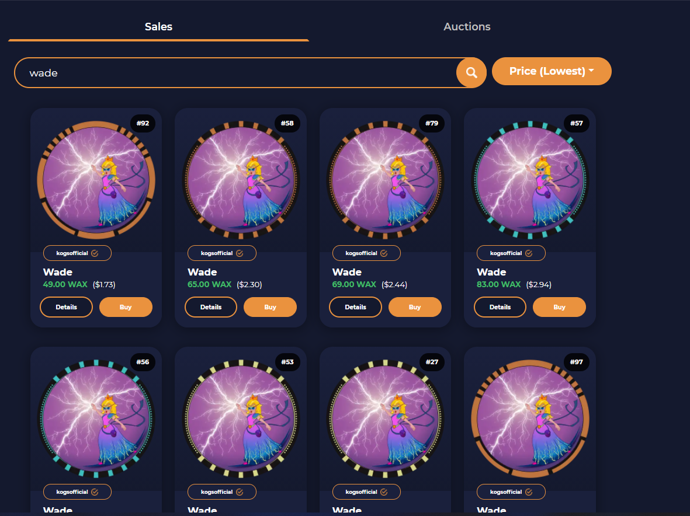

Lowest price

Ascending prices

Go into the parameters and type in the description

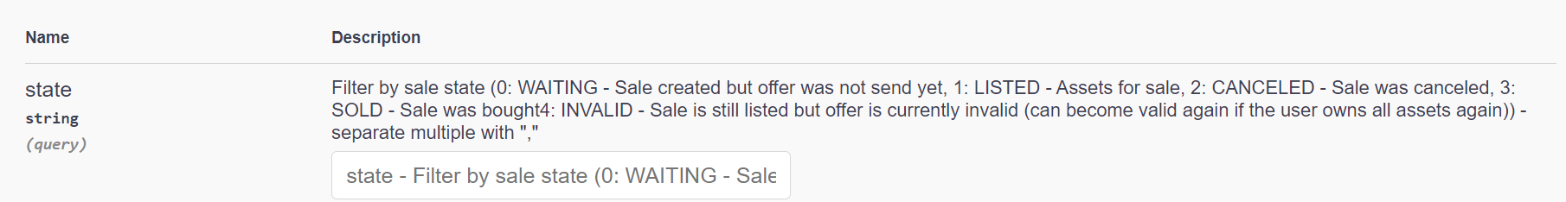

State:

|  |  |
| --- | --- |
| State | Description |
| 0 | Sales created but offer was not send yet |
| 1 | listed |
| 2 | cancelled |
| 3 | Sold |

Filled in 1 cause what we want is to get the assets that is already listed in the marketplace

## Copy the name of the of the collection name



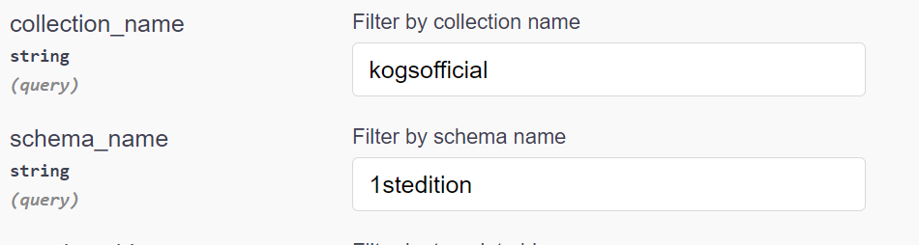



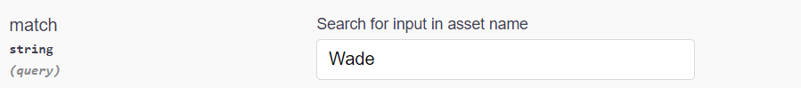

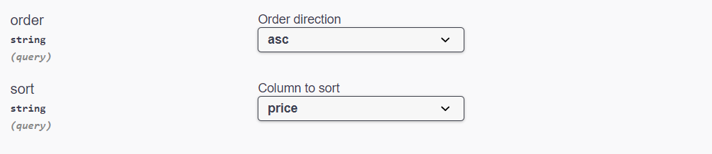

Then we can sort by price using the ascending sort price section and other selection also

After all the section is done we can execute the code to get the url in full

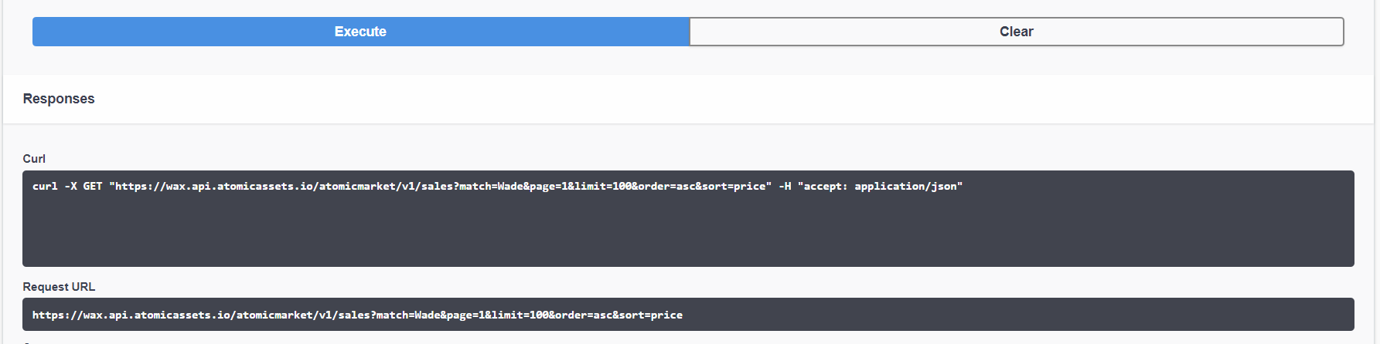

Copy your API LInk

All wee need is this particular API to run the following code

# 2.Method 2 witch is to copy the link at the top of browser



Start copy from the collection name section and then

|  |  |
| --- | --- |
| Default | Copied |
| **https://wax.api.atomicassets.io/atomicmarket/v1/sales?state=1&** |  |
| Combined them 2 together and paste the link | |